11.CODE:

import cv2

import numpy as np

from google.colab.patches import cv2_imshow

image = cv2.imread(r"pexels-souvenirpixels-414612.jpg")

rows, cols, ch = image.shape

pts1 = np.float32([[50, 50], [200, 50], [50, 200]])

pts2 = np.float32([[10, 100], [200, 50], [100, 250]])

matrix = cv2.getAffineTransform(pts1, pts2)

transformed_image = cv2.warpAffine(image, matrix, (cols, rows))

cv2_imshow(image)

cv2_imshow(transformed_image)

OUTPUT:

12.CODE:

import cv2

import numpy as np

from google.colab.patches import cv2_imshow

image = cv2.imread("pexels-souvenirpixels-414612.jpg")

if image is None:

print("Error: Image not found!")

exit()

pts1 = np.float32([[100, 100], [400, 100], [100, 400], [400, 400]])

pts2 = np.float32([[0, 0], [300, 0], [0, 300], [300, 300]])

matrix = cv2.getPerspectiveTransform(pts1, pts2)

output = cv2.warpPerspective(image, matrix, (300, 300))

cv2_imshow(image)

cv2_imshow(output)

cv2.imwrite("perspective_transformed.jpg", output)

OUTPUT:

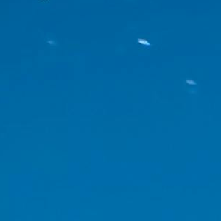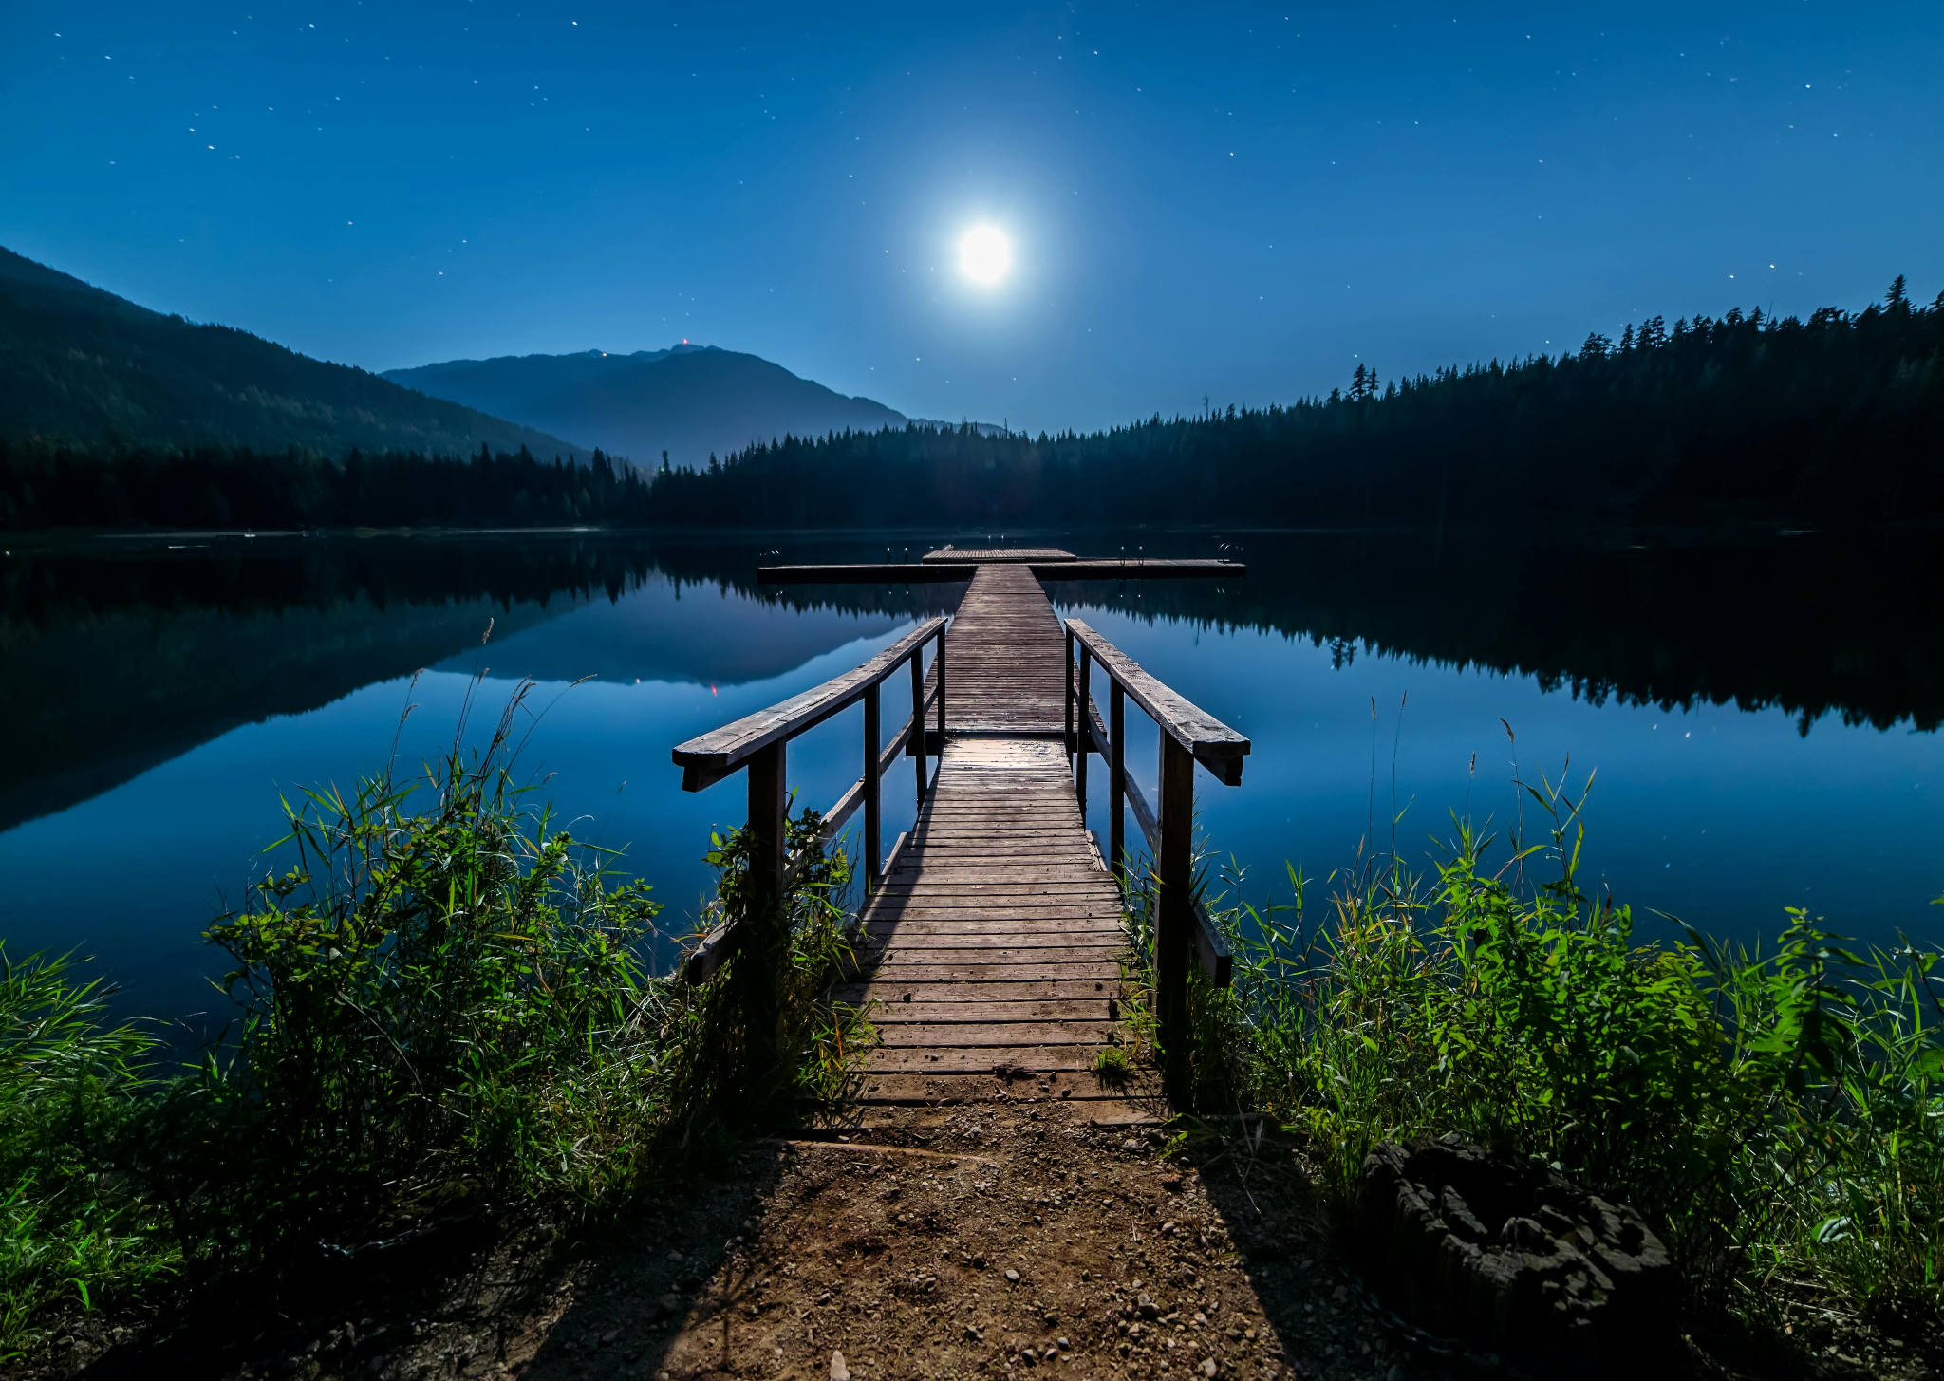

13:

CODE:

import cv2

import numpy as np

cap = cv2.VideoCapture("nature_video.mp4")

out = cv2.VideoWriter("transformed_video.mp4", cv2.VideoWriter_fourcc(*'mp4v'),

cap.get(cv2.CAP_PROP_FPS), (300, 300))

w = int(cap.get(3))

h = int(cap.get(4))

pts1 = np.float32([[50, 50], [w-50, 50], [50, h-50], [w-50, h-50]])

pts2 = np.float32([[0, 0], [300, 0], [0, 300], [300, 300]])

matrix = cv2.getPerspectiveTransform(pts1, pts2)

while True:

ret, frame = cap.read()

if not ret:

break

warped = cv2.warpPerspective(frame, matrix, (300, 300))

out.write(warped)

cap.release()

out.release()

OUTPUT:

VIDEO

14.CODE:

import cv2

import numpy as np

from google.colab.patches import cv2_imshow

image = cv2.imread('cv 14.jpg')

if image is None:

print("Error: Image not found!")

else:

src_pts = np.float32([[50, 50], [300, 50], [50, 300], [300, 300]])

dst_pts = np.float32([[0, 0], [400, 0], [0, 400], [400, 400]])

H, _ = cv2.findHomography(src_pts, dst_pts)

transformed_image = cv2.warpPerspective(image, H, (400, 400))

cv2_imshow(image)

cv2_imshow(transformed_image)

cv2.imwrite('transformed_image.jpg', transformed_image)

OUTPUT:



15:

CODE:

import cv2

import numpy as np

from google.colab.patches import cv2_imshow

image = cv2.imread('images.jpg')

if image is None:

print("Error: Image not found!")

else:

src_pts = np.float32([[50, 50], [300, 50], [50, 300], [300, 300]])

dst_pts = np.float32([[0, 0], [400, 0], [0, 400], [400, 400]])

A = []

for i in range(4):

x1, y1 = src_pts[i]

x2, y2 = dst_pts[i]

A.append([x1, y1, 1, 0, 0, 0, -x2*x1, -x2*y1, -x2])

A.append([0, 0, 0, x1, y1, 1, -y2*x1, -y2*y1, -y2])

A = np.array(A)

_, _, Vt = np.linalg.svd(A)

H = Vt[-1].reshape(3, 3)

transformed_image = cv2.warpPerspective(image, H, (400, 400))

cv2_imshow(image)

cv2_imshow(transformed_image)

cv2.imwrite('transformed_image_dlt.jpg', transformed_image)

OUTPUT:

